DOC GENIE

Naan Mudhalvan Project Report Submitted to Manonmaniam Sundaranar University in The Partial fulfilment of the Requirement for the award of the Degree of Bachelor of Science in Information Technology.

Submitted By

Team ID: SETID-2026-2483

Team Leader: ANTONY THREASA SNOWNLIN.M– 23082241808412005

Team Member: ASMA FAREEHA.AJ – 23082241808412006

Team Member: KASTHURI.M – 23082241808412018

Team Member: MEENAKSHI.K - 23082241808412025

Under The Guidance Of
Miss.R. Sherline Mercy M.CA., Assistant Professor


DEPARTMENT OF INFORMATION TECHNOLOGY WAVOO WAJEEHA WOMEN’S COLLEGE OF ARTS & SCIENCE
KAYALPATNAM – 628 204

APRIL – 2026

CERTIFICATE

WAVOO WAJEEHA WOMEN’S COLLEGE OF ARTS AND SCIENCE KAYALPATNAM – 628 204
CERTIFICATE
This is to certify that project entitled as

“DOC GENIE”

Is a Bonafide work done by
Team ID: SETID-2026-2483

Team Leader: ANTONY THREASA SNOWNLIN.M– 23082241808412005

Team Member: ASMA FAREEHA.AJ – 23082241808412006

Team Member: KASTHURI.M – 23082241808412018

Team Member: MEENAKSHI.K - 23082241808412025

In partial fulfillment of the requirement for B.Sc. Degree Course in Information Technology (2025-2026) of the Manonmaniam Sundaranar University for Naan Mudhalvan Course(Agentic AI Application Developer) is done .

Signature of the Staff Incharge

Signature of the H.O.D

EXTERNAL EXAMINERS 1.

2.

DECLARATION

DECLARATION

This project is submitted for the Naan Mudhalvan Course Agentic AI Application Developer Subject code and the external examination is conducted on .
.

Signature of the Candidates

- ANTONY THREASA SOWNLIN M

- ASMA FAREEHA AJ

- KASTHURI M

- MEENAKSHI K

DATE :

PLACE: Kayalpatnam

CONTENT

S.NO | TABLE OF CONTENT | PAGE NO
1. | PROJECT DESCRIPTION | 1
2. | SCENARIOS | 3
3. | ARCHITECTURE OVERVIEW | 5
4. | PROJECT WORKFLOW | 8
5. | PROJECT STRUCTURE | 12
6. | IMPLEMENTATION PHASE | 14
7. | SCREENSHOTS | 25
8. | Future Enhancements | 28
9. | CONCLUSION | 30

PROJECT DESCRIPTION

PROJECT DESCRIPTION

Doc Genie is an AI-based document management and generation system designed to help users easily create, analyze, and retrieve information from documents. The main goal of this project is to reduce the time and effort required to manually search, read, and prepare documents by using artificial intelligence and automation.

The system allows users to upload documents such as PDF, DOCX, and TXT files, and the AI automatically processes the content to understand the information inside them. After processing, users can ask questions in natural language and receive instant answers extracted directly from the uploaded documents. This makes it easier for students, professionals, and organizations to quickly find important information without reading the entire document manually.

Doc Genie also supports automatic document generation, where users can provide data (for example from spreadsheets or forms), and the system generates formatted documents such as reports, invoices, contracts, or summaries automatically. This feature helps businesses and individuals create multiple documents quickly while reducing human errors.

Another important feature of Doc Genie is AI-powered summarization and interactive chat. When users upload long documents, the system can automatically summarize the content and highlight the key points. Users can also interact with the document through a chat interface to better understand complex information.

Overall, the Doc Genie project improves productivity, document organization, and knowledge extraction by combining artificial intelligence, natural language processing (NLP), and document processing technologies. It is especially useful for students, researchers, businesses, and organizations that work with large numbers of documents and need faster access to important information.

SCENARIOS

SCENARIOS

Scenario 1: Student Study Assistance

Students often have long study materials such as PDFs, research papers, or notes. They can upload these documents into Doc Genie and ask questions about the content. The system analyzes the document and provides summaries or direct answers, helping students understand topics faster without reading the entire document.

Scenario 2: Business Document Management

Companies handle many documents such as reports, contracts, and policies. With Doc Genie, employees can upload these files and quickly search for specific information by asking questions. This saves time because the system finds the relevant sections automatically instead of manually searching through files.

Scenario 3: Legal Document Review

Lawyers and legal teams deal with long legal agreements and contracts. Doc Genie can summarize legal documents and highlight important clauses, making it easier to review agreements and understand key terms quickly. This improves efficiency and reduces the time spent on document analysis.

Scenario 4: Research and Data Analysis

Researchers often work with large numbers of reports and academic papers. By uploading these documents to Doc Genie, they can extract key insights, generate summaries, and quickly locate important information for their research work.

Scenario 5: Automated Document Creation

Businesses and professionals can use Doc Genie to automatically generate documents such as reports, proposals, and training guides. The AI system collects information and produces a well-formatted document, saving time compared to manual writing.

ARCHITECTUR OVERVIEW

ARCHITECTURE OVERVIEW

The architecture of Doc Genie is designed to process, analyze, and retrieve information from documents using artificial intelligence. The system is built with several layers and components that work together to upload, process, store, and answer questions about documents efficiently.

Core Technologies

• Python 3.8+: Primary programming language used to build and run the Doc Genie system.

• Gradio 4.0+: Framework used to create a simple web interface for interacting with the application.

• ReportLab: Library used to generate PDF documents such as reports and summaries.

• Regular Expressions: Technique used to find and process specific text patterns in documents.

• Google Colab: Cloud-based platform used to write, test, and run Python programs online.

• HTML5 / CSS3: Web technologies used to design and style the user interfa

Pre-requisites

Software Requirements

• Operating System: Windows / Linux / macOS used to run and support the Doc Genie application.

• Python 3.8+: Programming language required to develop and execute the system modules.

• Libraries / Frameworks: Tools such as Gradio, AST, and ReportLab used for interface design, code analysis, and PDF generation.

• IDE / Code Editor: Development tools like VS Code, PyCharm, or Jupyter Notebook used to write and manage the project code.

• Web Browser: Browsers such as Chrome or Firefox used to access and test the web interface of the system.

• PDF Viewer: Software like Adobe Reader or browser-based viewers used to open generated PDF reports.

Knowledge Prerequisi

• Python Fundamentals: Familiarity with Python syntax and basic libraries used for application development.

• Document Processing Concepts: Basic knowledge of how digital documents like PDF or text files are handled in software systems.

• Artificial Intelligence Basics: Understanding simple AI or machine learning concepts used for document analysis.

• Web Technologies: Basic knowledge of HTML, CSS, and web applications for creating user interfaces.

• Database Fundamentals: Understanding how data is stored, managed, and retrieved from databases.

Hardware Requirements

- System Hardware Specifications
- Required Hardware Components
- Hardware Configuration Details
- Minimum Hardware Setup
- Hardware Environment
Example (similar style):
- Hardware Requirements → System Hardware Specifications
- Hardware Requirements → Required Hardware Setup

PROJECT WORKFLOW

4.PROJECT WORKFLOW

Phase 1: System Preparation & Basic Framework

Task 1.1: Setting Up Required Tools & Environment

Prepare requirements.txt file including all necessary libraries

Configure Google Colab workspace with appropriate settings

Install essential modules such as gradio, transformers, torch, reportlab, requests

Confirm that all libraries are properly installed and the

Task 1.2: System Configuration & Dependency Verification

Update configuration files for proper project execution

Initialize project folders and required resources

Validate installed libraries and environment compatibility

Ensure all development tools are functioning correctly

Task 1.3: Development Tools Initialization

Prepare the workspace for coding and testing

Organize project folders and file structure

Connect required libraries and frameworks to the project

Perform a quick system check to ensure the setup is ready for development

Phase 2: System Development & Implementation

Task 2.1: Application Structure Creation

Design the overall system structure

Define modules and components required for the project

Prepare the initial code framework

Task 2.2: Core Feature Development

Implement the main functionalities of the system

Integrate required libraries and APIs

Ensure the program logic works correctly

Task 2.3: Initial Testing & Verification

Run the application to check basic functionality

Identify and fix early errors or bugs

Confirm the system works as expected

Phase 3: System Testing & Performance Evaluation

Task 3.1: Functional Testing

Test each module to ensure proper functionality

Verify that the system performs according to requirements

Task 3.2: Error Detection & Debugging

Identify system errors or unexpected behavior

Fix bugs and update the code accordingly

Task 3.3: Performance Validation

Evaluate system speed and response time

Confirm that the application runs efficiently

TECHNICAL STRUCTURE:

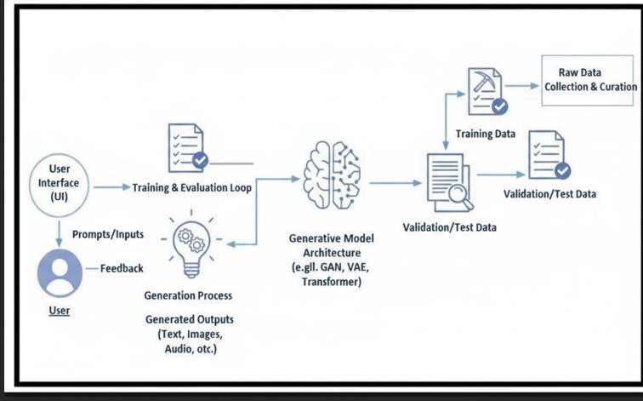

PROJECT STRUCTURE

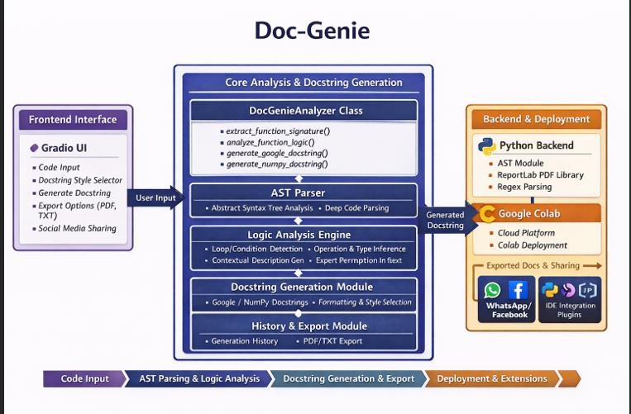
- PROJECT STRUCTURE

IMPLEMENTATION PHASE

5.IMPLEMENTATION PHASE

Activity 1.1: Install Dependencies
Create requirements.txt with the following dependencies:

- gradio==4.41.0
- transformers==4.35.0
- torch==2.0.0
- reportlab==4.0.7
- requests==2.31.0
- black==24.1.1
- autopep8==2.1.0
Install via: pip install -r requirements.txt import random
# Install required packages
!pip install -q gradio transformers torch black autopep8 reportlab requests ast-super-parser
# Imports
import gradio as gr
from datetime import datetime from pathlib import Path import json
import re import ast import requests
import urllib.parse import inspect

from reportlab.lib.pagesizes import letter, A4
from reportlab.platypus import SimpleDocTemplate, Paragraph, Spacer, PageBreak from reportlab.lib.styles import getSampleStyleSheet
from reportlab.lib.units import inch

# Folder create
output_folder = Path("reports")

output_folder.mkdir(exist_ok=True) styles = getSampleStyleSheet()
# Function to analyze python code def analyze_code(code):

lines = code.split("\n") line_count = len(lines) char_count = len(code)

try:
tree = ast.parse(code)
functions = [node.name for node in ast.walk(tree) if isinstance(node, ast.FunctionDef)] classes = [node.name for node in ast.walk(tree) if isinstance(node, ast.ClassDef)]
except:
functions = [] classes = []

result = f"""
Code Analysis Report

Total Lines : {line_count} Total Characters : {char_count} Functions Found : {functions} Classes Found : {classes}
"""

return result
Install required packages (run this once)
!pip install -q gradio transformers torch black autopep8 reportlab requests

# Imports
import gradio as gr import ast
from datetime import datetime from pathlib import Path import urllib.parse
from reportlab.lib.pagesizes import letter
from reportlab.platypus import SimpleDocTemplate, Paragraph, Spacer

# --- Analyzer Class ---

class DocGenieAnalyzer:
"""Analyze Python functions and generate professional docstrings"""

@staticmethod
def extract_function_signature(code):
"""Extract function name, parameters, return type from code""" try:
tree = ast.parse(code) func_def = tree.body[0]
if not isinstance(func_def, ast.FunctionDef): return None
func_name = func_def.name params = []
for arg in func_def.args.args: param_type = "Any"
if arg.annotation:
param_type = ast.unparse(arg.annotation) if hasattr(ast, "unparse") else

"Any"

params.append({"name": arg.arg, "type": param_type, "default": None}) return {"name": func_name, "params": params, "return_type": "Any"}

except Exception as e:
print("Error parsing function:", e) return None

@staticmethod
def analyze_function_logic(code): """Analyze function body logic""" analysis = {
"has_loops": False, "has_conditions": False, "has_return": False, "loop_types": [],

"condition_types": [], "operations": [],
"return_types": [], "variables_used": set(), "function_calls": [], "description": "",
}
try:
tree = ast.parse(code)
if not tree.body or not isinstance(tree.body[0], ast.FunctionDef): return analysis
func_def = tree.body[0]
for node in ast.walk(func_def):
if isinstance(node, (ast.For, ast.While)): analysis["has_loops"] = True
analysis["loop_types"].append("for" if isinstance(node, ast.For) else

"while")

if isinstance(node, (ast.If, ast.IfExp)): analysis["has_conditions"] = True analysis["condition_types"].append("if")
if isinstance(node, ast.Return): analysis["has_return"] = True
if isinstance(node, ast.Name) and isinstance(node.ctx, ast.Load): analysis["variables_used"].add(node.id)
if isinstance(node, ast.Call):
if isinstance(node.func, ast.Name): analysis["function_calls"].append(node.func.id)
elif isinstance(node.func, ast.Attribute): analysis["function_calls"].append(node.func.attr)

# Simple description
if analysis["has_loops"] and analysis["has_conditions"]:

logic."
analysis["description"] = "Iterates through data and applies conditional

elif analysis["has_loops"]:
analysis["description"] = "Processes data using iterative loops." elif analysis["has_conditions"]:
analysis["description"] = "Executes code based on conditions." elif analysis["has_return"]:
analysis["description"] = "Calculates and returns a result." else:
analysis["description"] = "Performs a sequence of operations."

except Exception as e:
print("Error analyzing function:", e) return analysis

@staticmethod
def generate_google_docstring(signature, analysis, code): """Generate Google-style docstring"""
summary = analysis.get("description", "Processes input and returns result.") docstring = f' """{summary}\n'
if signature and signature["params"]: docstring += "\n Args:\n"
for param in signature["params"]:
default_str = f" (default: {param['default']})" if param["default"] else "" docstring += f" {param['name']} ({param['type']}): Parameter for
controlling {param['name']} behavior{default_str}.\n"
docstring += f"\n Returns:\n {signature['return_type']}: The result of the computation.\n"
docstring += ' """\n' return docstring

@staticmethod
def generate_numpy_docstring(signature, analysis, code): """Generate NumPy-style docstring"""

summary = analysis.get("description", "Processes input and returns result.") docstring = f' """{summary}\n'
if signature and signature["params"]:
docstring += "\n Parameters\n \n"
for param in signature["params"]:
default_str = f", default: {param['default']}" if param["default"] else "" docstring += f" {param['name']} : {param['type']}{default_str}\n" docstring += f" Parameter for controlling {param['name']} behavior.\n"
docstring += f"\n Returns\n -------\n {signature['return_type']}\n" docstring += f" The result of the computation.\n"
docstring += ' """\n' return docstring

# --- Global Variables --- analyzer = DocGenieAnalyzer() generation_history = []

# --- Helper Functions ---
def generate_docstring(code, style): global generation_history
sig = analyzer.extract_function_signature(code) if not sig:
return code, "Error: Could not parse function signature." analysis = analyzer.analyze_function_logic(code)
if style == "google":
doc = analyzer.generate_google_docstring(sig, analysis, code) else:
doc = analyzer.generate_numpy_docstring(sig, analysis, code) # Insert docstring after def line
lines = code.splitlines()

for i, line in enumerate(lines):
if line.strip().startswith("def "):
indent = len(line) - len(line.lstrip()) + 4 lines.insert(i + 1, " " * (indent - 4) + doc) break
new_code = "\n".join(lines) generation_history.append((code, new_code, style)) return new_code, "Docstring generated successfully!"

def process_upload(file_obj): if file_obj is None:
return "", "No file uploaded." try:
with open(file_obj.name, "r") as f: content = f.read()
return content, f"File '{Path(file_obj.name).name}' uploaded successfully." except Exception as e:
return "", f"Error reading file: {e}"

def clear_history():
global generation_history generation_history = [] return "History cleared."

def download_txt():
global generation_history if not generation_history:
return None, "No generated docstrings." txt_content = ""

for original, generated, style in generation_history:
txt_content += f"Original Code:\n{original}\n\nGenerated {style.capitalize()} Docstring:\n{generated}\n\n{'-'*50}\n"
timestamp = datetime.now().strftime("%Y%m%d_%H%M%S") file_name = f"docstrings_{timestamp}.txt"
with open(file_name, "w", encoding="utf-8") as f: f.write(txt_content)
return file_name, "TXT file generated."

def generate_whatsapp_link(): if generation_history:
latest = generation_history[-1][1]
msg = f"Check out this Python code with a generated docstring:\n\n```python\n{latest}\n```"
return f"https://wa.me/?text={urllib.parse.quote(msg)}" return "No docstring generated."

def generate_facebook_link(): if generation_history:
latest = generation_history[-1][1]
dummy_url = "https://example.com/generated_code?code=" + urllib.parse.quote(latest)
return f"https://www.facebook.com/sharer/sharer.php?u={dummy_url}" return "No docstring generated."

# --- Gradio Interface ---
with gr.Blocks(title="DocGenie: AI-Powered Docstring Generator") as demo:
gr.Markdown("## Professional Python Function Docstring Generator") gr.Markdown("Transform your Python functions with AI-powered, accurate
documentation!")

with gr.Row():
with gr.Column(scale=3): gr.Markdown("### Input Function Code") code_input = gr.Code(
language="python", label="Python Function", lines=10,
value="def calculate_factorial(n):\n if n == 0:\n return 1\n return n * calculate_factorial(n-1)"
)
file_upload = gr.File(label="Or Upload .py File", file_types=[".py"])
upload_status = gr.Textbox(label="Upload Status", interactive=False, lines=1) file_upload.change(process_upload, inputs=[file_upload], outputs=[code_input,
upload_status])

docstring_style = gr.Radio(["google", "numpy"], value="google", label="Docstring Style")
generate_btn = gr.Button("Generate Docstring", size="lg", variant="primary", scale=2)

with gr.Column(scale=2): gr.Markdown("### Generated Output")
code_output = gr.Code(language="python", label="Function with Docstring", lines=15, interactive=False)
gen_status = gr.Textbox(label="Status", interactive=False, lines=1)

generate_btn.click(generate_docstring, inputs=[code_input, docstring_style], outputs=[code_output, gen_status])

with gr.Column(scale=1): gr.Markdown("### Controls")
clear_btn = gr.Button("Clear History", variant="stop", size="sm") clear_btn.click(clear_history, outputs=[upload_status])

gr.Markdown("---") gr.Markdown("### Export")
txt_btn = gr.Button("Download TXT", size="sm", variant="primary") txt_file = gr.File(label="TXT File", interactive=False, visible=True) txt_btn.click(download_txt, outputs=[txt_file, gen_status])

gr.Markdown("---") gr.Markdown("### Share")
whatsapp_btn = gr.Button("WhatsApp", size="sm", variant="secondary") facebook_btn = gr.Button("Facebook", size="sm", variant="secondary") share_output = gr.Textbox(label="Share Link", interactive=False, lines=4) whatsapp_btn.click(generate_whatsapp_link, outputs=[share_output]) facebook_btn.click(generate_facebook_link, outputs=[share_output])

# Launch demo.launch()

SCREENSHOTS

8.SCREENSHOTS

Application Running in Google Colab 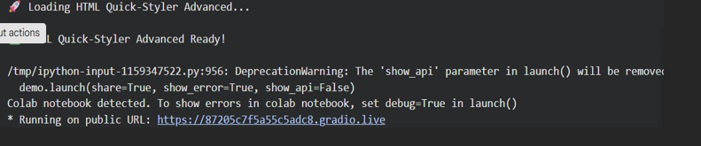
- Generated Gradio Public URL

Public URL: : https://87205c7f5a55c5adc8.gradio.live
This screenshot shows the public URL generated by Gradio which allows users to access the application through a web browser.

- Website Generation Input Interface
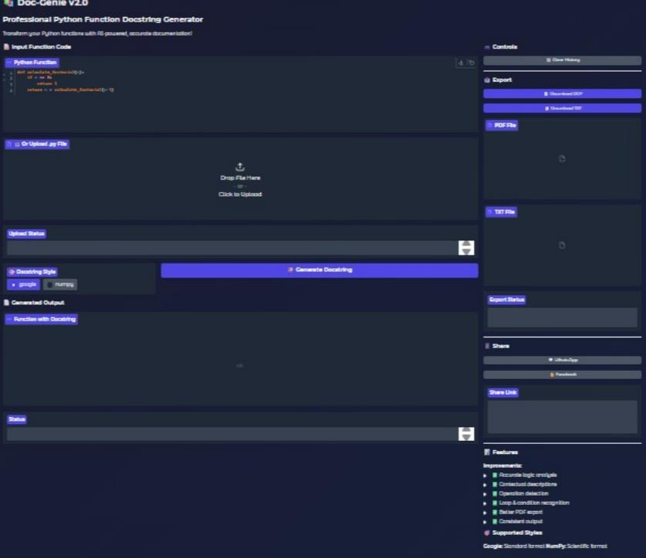

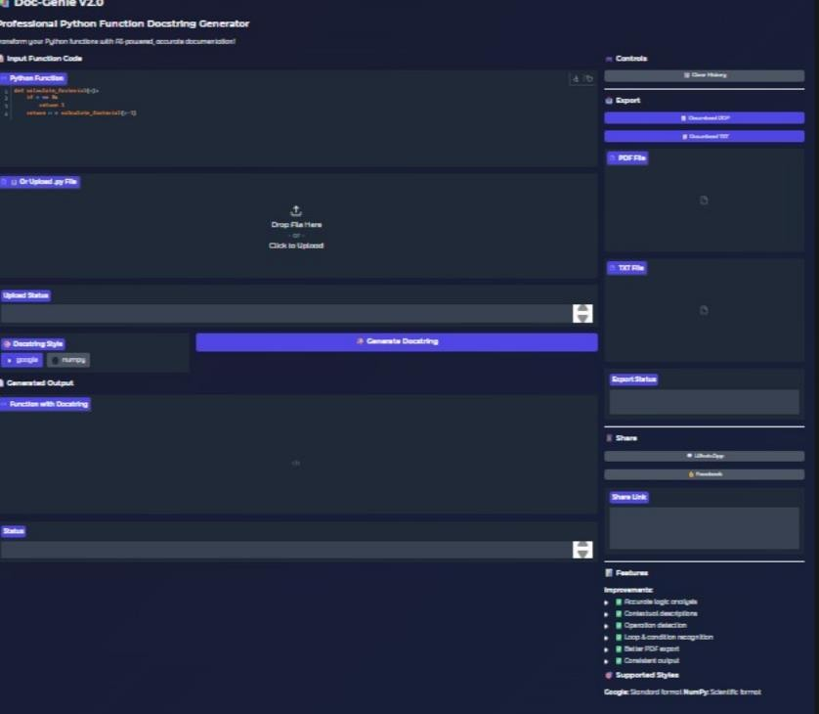

Future Enhancements

8. Future Enhancements

In the upcoming stages of development, Doc-Genie can be enriched with a wide range of advanced features that will elevate its usability and professional scope. Planned improvements include:

- Multi-language support: Extending documentation generation beyond Python to cover Java, C++, and JavaScript, thereby making the platform versatile across diverse programming paradigms.

- IDE integration: Seamless plugins for popular IDEs like VSCode and PyCharm, enabling developers to generate documentation directly within their coding environment.

- AI-powered analysis: Incorporating machine learning techniques to automatically generate detailed function descriptions, enforce documentation styles, and recommend best practices.

- Comprehensive coverage: Expanding support to include class-level and module-leveldocumentation, ensuring complete coverage of codebases.

- Automated deployment: Direct integration with GitHub and GitLab for automatic publishing of documentation, reducing manual effort and streamlining workflows.

- Compatibility with existing tools: Integration with documentation generators such as Sphinx and MkDocs, allowing developers to merge Doc-Genie’s outputs with established documentation pipelines.

- Quality metrics: Real-time code quality analysis with documentation metrics, helping teams monitor technical debt and maintain high standards.

- Future intelligence: Advanced logic for identifying gaps, suggesting improvements, and ensuring professional documentation standards across projects.

CONCLUSION

9.CONCLUSION

Doc-Genie has successfully demonstrated its potential as an intelligent Python documentation assistant. By combining advanced Abstract Syntax Tree (AST) analysis with intuitive documentation generation through Gradio’s interactive interface, the system ensures fast, accurate, and professional outputs. Leveraging Python’s introspection capabilities and sophisticated code analysis algorithms, Doc-Genie provides developers, teams, and educators with a reliable platform for maintaining well-structured codebases.

The platform highlights the viability of intelligent documentation systems, making professional Python documentation generation accessible while preserving analysis accuracy, documentation quality, and adherence to industry-standard docstring formats. With features such as advanced logic analysis, multiple documentation styles, comprehensive export options, and even social media sharing, Doc-Genie empowers developers to maintain clarity and consistency in their projects.

Looking ahead, Doc-Genie is positioned to evolve into a comprehensive documentation ecosystem. Its modular architecture allows for future enhancements such as multi-language support, IDE integration, AI-powered recommendations, and real-time quality metrics. These improvements will strengthen its role as a professional documentation platform, ensuring scalability, adaptability, and long-term relevance in diverse programming environments.

In essence, Doc-Genie not only addresses current documentation challenges but also lays the foundation for a forward-looking, intelligent, and user-friendly documentation solution.

